**Leader Overview**

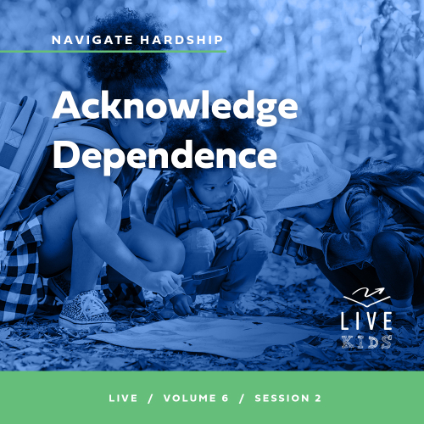

**Volume Overview**

**Navigate Hardship**

*Life is hard, even for believers. We all know it or discover it soon enough. Life tests our patience, our hope, and our sense of God’s presence. But we are not left hopeless in our challenges. God’s presence is more certain than even our hardships. Still, there are times in life that we need to be reminded that He is present. It’s in hardships that we learn to recognize it. We also learn to depend on God, to wait, and to look forward to His rescue.*

**Session Overview**

**Acknowledge Dependence**

*In this* **Live** *session, kids will discover that they can depend on God, even in situations that seem hopeless or where the timing of God’s answer to prayer is delayed. The story of Zechariah and Elizabeth waiting on God for a son shows us how to depend on Him in a special way. Trusting God like this teaches us things about Him and ourself that we couldn’t learn if all our problems were solved the moment they arose.*

**Bible Lesson**

Zechariah and Elizabeth’s Wait Is Over

[Luke 1:6–25](https://ref.ly/logosref/Bible.Lk1.6-25), [57–66](https://ref.ly/logosref/Bible.Lk1.57-66)

**Faith Fact**

I can trust God to answer.

**Faith Verse**

[Psalm 34:19](https://ref.ly/logosref/Bible.Ps34.19) (NLT)

The righteous person faces many troubles, but the Lord comes to the rescue each time.

**Preparing for the Session**

**Leader Preparation Time: 20–25 Minutes**

|  |
| --- |
| ***You Will Need***  ***Large Group***   * *Bible* * *Worship songs (Song suggestions: “Nothing is Impossible” Lyric Video by Planetshakers; “Only Wanna Sing” Lyric Video by Hillsong Young & Free: “Trust” Lyric Video by Hillsong Young and Free, “Surrounded (Fight My Battles)” Lyric Video by Upper Room)* * *For groups not using a phone or tablet only, add:*   *• Projector or TV*  *• Laptop*  *•* ***Faith Fact Slide***  *•* ***Faith Verse Video*** *or* ***Slide***  *•* ***Bible Lesson Video***  *•* ***Teaching Point Slides 1–3***  *•* ***Large Group Game Page***   * *Scissors* * *Cup or bowl* * *Tape* * *Three sheets of paper* * *Marker* * *Tape*   ***Small Group***   * *Plates or napkins, one per kid* * *Large marshmallows, two per kid* * *Bibles for kids in the group to share* * ***Small Group Faith Verse Review****, one set per team* * *Scissors* * *Optional: Smartphone to time activity* * ***Small Group Activity Page****, one per kid* * ***Small Group Activity Page Answer Page****, if needed* * *Pencils or pens, one per kid*   *To access session content and videos from a computer, visit:* [*BibleEngagementProject.com/downloads*](https://bibleengagementproject.com/downloads) |
| ***Getting Ready***  ***Large Group***   * *Download videos and slides if needed.* * *Select worship song(s) and have them ready to play.* * *Read the Bible Lesson Scripture to prepare for Teaching Time.* * *Print the* ***Large Group Game Page****.* * *Cut apart the numbered slips.* * *Tape the four larger numbers to the wall, one in each corner of the room.* * *Fold the smaller numbered slips and place in a cup.* * *Write one word—Wait, Hear, and Obey—on each piece of paper.* * *Tape the words in different places in the room.*   ***Small Group***   * *Have an adult volunteer watch the group who knows what to do. Volunteer should stir up tension with kids about eating the snack.* * *Print copies of the* ***Small Group Faith Verse Review****, one set per team.* * *Cut apart the slips for each team.* * *Print copies of the* ***Small Group Activity Page****, one per kid.* * *Print the S****mall Group Activity Page Answer Page****, if needed.*   *First time leading* Live *for Kids? Check out the* [*Facilitator Guide*](https://0b769b0ed3569ef9d18b-f88d8272f61086866d50d048b43ef630.ssl.cf2.rackcdn.com/sites/biblengagementproject/Listen_Facilitator_Guide.pdf)*.* |

**Large Group**

**30 Minutes**

*See what’s needed at the beginning of the session.*

**Introduction**

Hey, everyone! It’s great to see all of you today! Together we’ll learn more about how to navigate the hardships that we face in our life. Navigating hardship means getting through tough times. God doesn’t promise to take away all tough times in our life, but He will take us through them. Raise your hand if you want to learn more about that today. *(Group response)*

Now, put your hand up if you hate waiting for things. *(Group response)* Waiting can be really difficult. Sometimes we must wait. It can be hard and even discouraging to wait. But the good news is that God helps us through the waiting.

Who has ever been promised something by your parents or someone else that you had to wait a long time for? *(Group response)* Even when you get promised something amazing—going to your favorite game store, buying new shoes, or going on a family vacation—waiting for those promises can be miserable. What’s something you’ve had to wait a long time for? *(Allow responses.)* Those are all awesome examples. Waiting can be very frustrating, even when it’s for something good.

**Faith Fact**

Waiting for good things reminds me of our Faith Fact for today: **I can trust God to answer**. In our Bible story, we’ll hear about two people who had to wait a long time for God to answer their prayer.

• *Show the* ***Faith Fact Slide.***

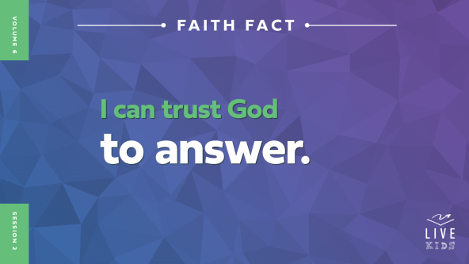

Sometimes waiting on God to answer our prayers can be frustrating. It can be even more difficult if we are waiting for God to do something He’s promised or if we’re in the middle of a tough situation in our life. Has anyone here ever felt frustrated like that before? *(Group response)* I have, too. But I know that God will always answer us in some way. Point up to the sky and back to yourself and say, **I can trust God to answer.** One more time. **I can trust God to answer.** Well done!

**Game**

**Four Corners**

Let’s play a game called Four Corners. Each corner has a number.

• *Point to the corners and number them 1, 2, 3, and 4.*

For our game, everyone will choose one of the numbers and go stand in that corner. Then, I’ll choose a volunteer to pick a number from the cup. If that number matches the corner you’re in, you’re out and must return to your seat. Let’s get started!

• *After each round, put the number slip back in the cup.*

• *Let remaining kids choose new corners and draw a number again.*

• *Keep playing until you have one winner or run out of time.*

• *Optional: If you don’t have much time to play the game, have kids choose a corner and stay there. Draw each slip and have kids in that corner sit down. When one slip is left, allow the remaining kids to move to a new corner and repeat until only one kid is left standing.*

• *Optional: If your group is too large to move around the room, have kids choose one of four actions instead of choosing a corner—stay seated, stand, sit on the floor, touch your toes, etc.*

Wow, you did a great job playing that game! Was it hard to pick the right corner? *(Group response)* Of course it was because this game isn’t one that you could figure out and win by skill. It was all random. How many of you like games like that? *(Group response)* How many don’t? *(Group response)*

Life can be the same way. It can be hard to be in situations that feel like they are totally out of our control. When we face times in life like that, we need to remember our Faith Fact. Let’s say the Faith Fact together. **I can trust God to answer.** He will be with us in those times.

**Worship**

One thing that helps us to trust that God will answer us, even in hopeless situations, is to worship Him. When we worship Him, we remind ourself who God is and how much He cares about us. We can trust that He will answer us when it’s the right time. Who’s ready to worship God? *(Group response)* One way we can worship God is by singing. Let’s worship Him together.

• *Lead the kids in singing one or two praise songs. See suggestions at the beginning of the session.*

**Bible Lesson**

Thanks for worshipping with me and remembering how amazing God has been to us. The best encouragement to trust God is knowing that He loves us. Remember our Faith Fact: **I can trust God to answer**. We’ll see what the Bible says about trusting God when it’s not easy. Let’s pray as we get started.

**Prayer**

|  |
| --- |
| *Dear God, thank You for being Someone that we can trust. As we hear from Your Word today, please help us learn how we can trust You, even in the middle of situations that seem hopeless or require waiting a long time. In Jesus’ name we pray. Amen.* |

**Video Intro**

Just before we look at the Bible story, let’s watch this video.

• *Play* ***Bible Lesson Video***.

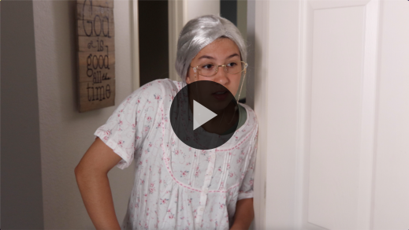

**Bible Story**

**Zechariah and Elizabeth’s Wait Is Over**

Have any of you ever been in a situation like Isa was in? *(Group response)* You have an idea in your mind of what you should be able to do, but no matter what you try, you are hopelessly stuck. Maybe, you do all the right things, but you still don’t see what you thought was supposed to happen. That can be tough! Let’s take a closer look at the Bible story Isa was talking about to find out more about how to handle times like these.

**Teaching Time**

In our Bible story, Jesus hadn’t been born yet. It was close to happening, but still several months away. There was a couple named Zechariah and Elizabeth. Zechariah was a priest. That means he worked in the temple sometimes. We’ll find out that the Bible says they were good, faithful, and God-honoring people.

Zechariah and Elizabeth faced a tough situation though. They really wanted to have a family of their own, but they couldn’t have any kids. How do you think this made them feel? *(Allow responses.)* Even though they honored God, they had to face that they probably wouldn’t ever have a baby of their own. The Bible says that by this time they were very old, maybe older than your grandparents. They may have given up hope that Elizabeth would become pregnant. Let’s see how Zechariah and Elizabeth reacted when something unbelievable happened to them.

Grab your Bible or pull up a Bible app on your device. Turn to [Luke 1](https://ref.ly/logosref/Bible.Lk1).

• *In order to keep Large Group time moving along, we recommend that the leader reads the Scripture portions aloud.*

• *Optional: Remind the kids to mark this place with their Bible bookmark so they can read it on their own at home.*

**1. God made a big promise.**

• *Show the* ***Teaching Point 1 Slide.***

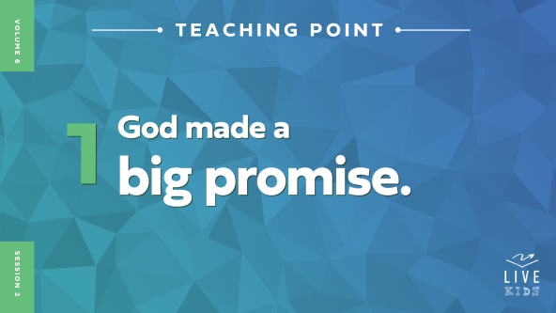

• *Read* [*Luke 1:6–17*](https://ref.ly/logosref/Bible.Lk1.6-17).

There was a lot that just happened in our Bible story. Did you catch all of it? While Zechariah was on priest duty at the temple, an angel came to tell him some amazing news. After all this time, their prayers had been heard and were about to be answered. He and Elizabeth would have a baby, a very special son who would be great in God’s eyes. It was truly an incredible moment for Zechariah and Elizabeth. In fact, it seemed almost too good to be true.

Think about it like this. What’s something amazing that you would love to have? *(Allow responses.)* What if I said I would give you what you wanted very soon*.* Would you believe me? *(Group response)* Hmm. Well you know what? If you promised me that, I wouldn’t believe you either. What if an angel from God made a promise to you? Would you believe the angel? *(Group response)* Let’s find out if Zechariah believed what the angel said to him.

* *Read* [*Luke 1:18–22*](https://ref.ly/logosref/Bible.Lk1.18-22)*.*

Did Zechariah believe what he was hearing? *(Group response)* Why do you think he responded to the angel this way? *(Allow responses.)* Remember he and Elizabeth had probably prayed for a baby for many, many years. When they got old, they may have given up hope of ever having a baby. What happened because Zechariah questioned God’s plan? *(Allow responses.)*

Because he didn’t believe the angel, Zechariah wasn’t able to speak until their baby was born. That’s around nine months of not talking! Can you imagine not being able to talk at all for that long? *(Group response)* That should make someone think twice before questioning God again, right?

The angel’s words came to pass, and Elizabeth became pregnant with a son. God made a big promise to Zechariah after he and Elizabeth had the faith to pray big prayers. Even in a hopeless situation like waiting years for God to answer their prayer, God still remembered Zechariah and Elizabeth and gave them a baby who would do amazing things.

In the same way, we must keep trusting God to answer our prayers. We don’t always know when that will happen or how long we have to wait. We may feel hopeless before our prayers are answered. However, we can trust that God hears us and will do what is best in our life. Let’s see what happened after Zechariah and Elizabeth received this amazing news.

**2. God’s promise came true.**

• *Show the* ***Teaching Point 2 Slide.***

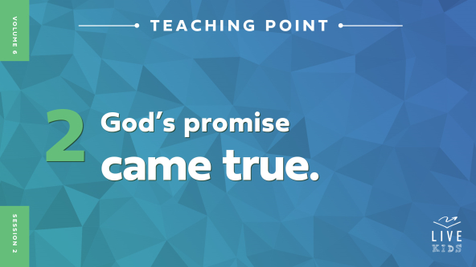

• *Read* [*Luke 1:23–25*](https://ref.ly/logosref/Bible.Lk1.23-25)*,* [*57–58*](https://ref.ly/logosref/Bible.Lk1.57-58)*.*

Elizabeth became pregnant and gave birth to a son just like the angel said. Every one of their friends and neighbors knew this was a huge gift from God, and they celebrated with them. Why do you think having a baby was such a big deal to Elizabeth? *(Allow responses.)*

One thing that’s important to know is that in Bible times, people looked down on a woman if she didn’t have kids. This answer to Elizabeth’s prayer meant that she would not only have a family of her own, but also would have honor from people in her town. Isn’t it amazing that God answered her prayers in a wonderful way? *(Group response)* She had to wait a long time for God to answer, and sometimes we have to wait for answers to our prayers.

• *Insert a personal, brief story that kids can relate to about waiting on God for something during a hopeless situation. This could be when you had to make a huge decision, when things at school or home were difficult, etc.*

We can trust that God will answer our prayers. The timing of when that happens is something we can’t know for sure. Whether you feel like God isn’t listening or that He’s being slow to fulfill His promise, you can still trust that He will answer.

Being in situations like this cause us to depend on Him. This is a really good thing! If we never had to depend on God, we wouldn’t have trust built up in Him. Zechariah struggled to trust what God said. The angel told Zechariah that he wouldn’t be able to speak until after the baby was born. Let’s see what happened!

**3. Zechariah honored God’s promise.**

• *Show the* ***Teaching Point 3 Slide.***

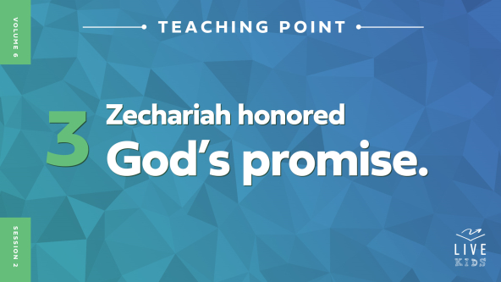

• *Read* [*Luke 1:59–66*](https://ref.ly/logosref/Bible.Lk1.59-66).

What does everyone want to know when a baby is born? *(Group response)* Right, the name of the baby. Sometimes, it’s normal to name a first son after his dad. Are any of you named after your dad or someone in your family? Raise your hand. *(Group response)* Since Zechariah couldn’t speak, all the people were telling Elizabeth she should do that and name her baby Zechariah. Did she agree with them? (*Group response)* No! She obeyed what the angel of God had told Zechariah.

Then, Zechariah wrote out what the baby’s name would be, and immediately he was able to speak after not talking for months. Why do you think he was able to speak again at just that time? *(Allow responses.)*

The angel had told Zechariah this would happen because of his unbelief. Once Zechariah honored God’s instructions about the baby’s name and called him John, he could speak again. Everyone was curious about what this baby would end up doing for God because it was clear that God had something special in mind.

Zechariah shows us that when God tells us to do something, we should do it. If He tells us that He is going to do something, we should believe Him. Now, I don’t think you need to be worried about God making you unable to talk like Zechariah, but it’s very important to learn to honor and believe what God says right away. How do you think Zechariah trusted God differently after all this happened? *(Allow responses.)*

Think about this. Would you rather follow directions on how to make the best slime from me or from an expert whose whole YouTube channel is dedicated to making slime? *(Group response)* You should listen to the expert because that person knows what they are talking about, right? Well, God is the expert on everything. We can trust that He knows what He’s doing. Following His directions and guidance, even in the middle of hopeless situations, is the right choice.

If you find yourself in a hopeless situation like Zechariah and Elizabeth, do everything you can to wait on God to answer your prayers. When He does, obey God and do what He’s telling you to do. Even when we wait a long time or when our situation is extremely hard to navigate, God is with us and will answer our prayers when we seek Him.

Remember our Faith Fact today: **I can trust God to answer**. While He may not always answer right away or answer what you want to hear, He will answer you and help you do what He’s telling you to do.

**Prayer and Response**

*Consider playing a worship song softly in the background while kids pray.*

God wants us to trust Him no matter what we might be going through. He wants to help us have patience, be strong, and be willing to follow His directions. We’ll pray and ask God to help us as we wait, hear, and obey the answers He gives us. Here’s what I want you to do. Think about a situation in your life right now that is hard for you. Then, we’ll gather in three groups for prayer today.

• *Indicate where you want kids to gather for each prayer focus (Wait, Hear, Obey) as you give the instructions.*

One group will pray about waiting for God to answer. If you feel like you’re still waiting on God for something to happen, gather with the Wait group.

If you feel like you’re not sure you know how to hear what God wants to say to you, join with the Hear group.

If you know what God has spoken to you, and you now need to obey what God is telling you to do, join the Obey group. Then, we’ll pray together.

• *Pause while kids choose their group.*

**Prayer**

*Optional: Have the kids repeat phrases of the prayer after you.*

|  |
| --- |
| *Dear God, thank You for being with me always. Help me to have patience when it feels like I have been waiting forever for Your answer to my prayer. Help me to hear Your direction and to know You are with me. Help me to obey what You’re telling me to do. I trust that You will answer my prayers at the perfect time, every time. In Jesus’ name. Amen.* |

**Faith Verse**

Our Faith Verse reminds us that God comes to our rescue. We can always trust He is with us.

• *Play* ***Faith Verse Video***.



[Psalm 34:19](https://ref.ly/logosref/Bible.Ps34.19) (NLT)

The righteous person faces many troubles, but the Lord comes to the rescue each time.

Let’s say that verse together. *(Group response)* Wonderful! Let’s try to say it as if we were tiny mice. *(Group response)* Let’s say that verse one more time as if we were big grizzly bears. *(Group response)*

**Faith Fact**

We’ve talked a lot about trusting God today. Before we go to our small groups, let’s say our Faith Fact again. **I can trust God to answer.**

• *Show the* ***Faith Fact Slide***.



Point at the sky and then point back at yourself. Let’s say it again. **I can trust God to answer.**

• *Dismiss kids to Small Group time or to go home if your group time ends here.*

**Small Group**

**30 Minutes**

*This section can be done in conjunction with the large group or on its own if you do small groups with your kids. During Small Group time, the goal is to connect the kids with the Word of God and to each other. All activities are led by the small group leader.*

**Group Connection**

**Waiting Test**

|  |
| --- |
| ***You Will Need***   * *Plates or napkins, one per kid* * *Large marshmallows, two per kid*   ***Getting Ready***   * *Have an adult volunteer watch the group who knows what to do. Volunteer should stir up tension with kids about eating the snack.* |

Our Bible story today taught us that even though waiting can be hard, God can help us through difficult situations. We need to be patient and obedient. When we remember that God loves us and that we can trust Him, it makes it easier to go through challenging times like Zechariah and Elizabeth did.

• *This activity requires that at least one leader stay with the kids. Never leave the kids unsupervised.*

I have a snack for each of you. How many of you like marshmallows? *(Group response)* They are so soft and fluffy, and they make a tasty snack. I’ll give each of you a marshmallow.

• *Hand out a plate and* ***one*** *marshmallow per kid.*

Now, you each have one. *(Start to act here.)* Oh! I think I forgot something. Don’t eat them yet! Wait until I get back. Give me two minutes!

• *Step out of sight of the group for two minutes.*

• *Volunteer should ask kids if you really meant that they shouldn’t eat the marshmallow, suggesting to them that it would be okay to eat their snack.*

• *Return to the group after a couple of minutes.*

Okay, I’m back! Now, does everyone still have a marshmallow? *(Group response)* If you do, congratulations! You passed the Waiting Test. For your patience, you get a second marshmallow.

• *Give a second marshmallow to the kids who waited for instructions.*

How many of you had a hard time being patient? *(Allow responses.)* Waiting can be hard, and we can want to do things our own way when God doesn’t answer us right away. When we ask God for help, we can trust that He will answer our prayers at just the right time. We need to wait patiently until He does.

**Bible Lesson Recap**

• *If small group activities are not immediately following large group time, you may want to read the Bible story passage before the discussion.*

|  |
| --- |
| ***You Will Need***   * *Bibles for kids in the group to share*   *No prep needed for this activity.* |

**Bible Story Review: Zechariah and Elizabeth’s Wait Is Over** [**Luke 1:6–25**](https://ref.ly/logosref/Bible.Lk1.6-25)**,** [**57–66**](https://ref.ly/logosref/Bible.Lk1.57-66)

What was the most interesting thing about the Bible story we read? *(Allow responses.)* Those are great answers! To review, Zechariah and Elizabeth prayed for a baby. After a long wait, they were promised a baby, even in their old age. It happened as God said, and Zechariah’s obedience after the baby’s birth led to him being able to speak again.

Why should Zechariah have trusted God more? *(Allow responses.)* God is good, and He will never make us promises He doesn’t keep. Even when we’ve been waiting for a long time in a hopeless situation, we can trust that God will do what He has said He will.

• *Give each kid a Bible and read the Bible story together.*

**Group Discussion**

*Feel free to use all or just a few questions as a jumping-off place for good discussion. Questions marked with * are designed for more conversation. Adjust the questions based on the age or maturity of your group. Typically, older kids will be able to dive a little deeper than younger ones.*

**Questions**

How would you describe Zechariah and Elizabeth to someone who hadn’t met them?

What did they want and pray about for many years?

* What happened when Zechariah went into the temple?

Why did God silence Zechariah?

How do you think Elizabeth felt when Zechariah let her know what happened at the temple? Why?

How did Zechariah and Elizabeth’s miracle impact their neighbors?

* Have you ever had to trust God during a hopeless situation? What happened?

* Is there something you’ve been praying about for a long time, and you’re still waiting for God to answer? How can this story help you and others?

* How can you trust God more this week?

**Live It**

**Faith Fact**

Our Faith Fact today is **I can trust God to answer.** Zechariah and Elizabeth learned that God heard their prayers. They obeyed Him even when His promise seemed too good to be true. Like them, we can trust that God is with us in every moment and in every situation. When we know this and remember it, our hopelessness becomes hopeful, and our waiting doesn’t seem like it takes so long.

**Challenge**

Here’s our challenge for the week. You never know what kind of prayer someone is waiting for God to answer. Maybe someone at your school or on your sports team is praying for a friend because they feel lonely. You could be an answer to someone else’s prayer. Look for chances to obey God like Zechariah was told to.

**Prayer**

*Finish group discussion by sharing prayer requests and praise reports. Keep track of your small group’s prayer requests and review them each time you meet.*

• *Have kids share and pray for each other’s prayer requests.*

|  |
| --- |
| *Dear God, thank You for answering us when You know it is the right time. Help us to have joy, patience, and trust in You and Your faithfulness while we wait to hear from You. In Jesus’ name. Amen.* |

**Faith Verse Review**

|  |
| --- |
| ***You Will Need***   * ***Small Group Faith Verse Review****, one set per team* * *Scissors* * *Optional: Smartphone to time activity*   ***Getting Ready***   * *Print copies of the* ***Small Group Faith Verse Review****, one set per team.* * *Cut apart the slips for each team.* |

Our Faith Verse is [Psalm 34:19](https://ref.ly/logosref/Bible.Ps34.19). It reminds us that God wants us to trust that He is with us when we face troubles in our life. Let’s go over it together.

• *Show* ***Faith Verse Video***.



[Psalm 34:19](https://ref.ly/logosref/Bible.Ps34.19) (NLT)

The righteous person faces many troubles, but the Lord comes to the rescue each time.

When we trust that God is with us, we can have peace that could only come from God. Let’s review our Faith Verse one more time. Try to memorize it as best as you can because you will need to know it for the Faith Verse game.

• *Say the verse together.*

**Faith Verse Fun**

**Unscramble It!**

All right, now it’s time to put our knowledge of the Faith Verse to the test. Everyone will get a slip with words from the Faith Verse. The goal is to see how quickly we can sort the words in the correct order of the verse.

• *Form at least two teams.*

• *If your group is large enough, have the kids hold up their words and stand in the correct order. If not, have them lay the words out in order.*

• *Optional: Challenge them to a speed competition against the clock or other groups.*

Great job, everyone! Memorizing this Faith Verse will help to transform your mind so that you can have greater trust in God. In every hard situation we face, we can remember that we are not alone. God is with us.

**Activity Page**

**Word Search**

|  |
| --- |
| ***You Will Need***   * ***Small Group Activity Page****, one per kid* * ***Small Group Activity Page Answer Page*** * *Pencils or pens, one per kid*   ***Getting Ready***   * *Print copies of the* ***Small Group Activity Page****, one per kid.* * *Print the* ***Small Group Activity Page Answer Page****, if needed.* |

Our Faith Fact today is **I can trust God to answer.** We talked about what we can do to remind ourself and others that God is with us.

• *Hand out a copy of the* ***Small Group Activity Page*** *and a pencil to each kid.*

Today, our Activity Page challenge is a word search about our Bible story. Let’s see if you can find all the words. Then, follow the instructions to see what we call Zechariah and Elizabeth’s son now.

• *Assist kids as needed. Younger kids may benefit from partnering with someone older.*

**Dismissal**

Remember God wants us to trust that He will lead us through the hard times we face. When we follow Him, He will be with us through anything that comes our way.

**Prayer**

|  |
| --- |
| *Dear God, please help us to have patience, joy, and trust whenever we face hopeless situations and have to wait for answers to our prayers. Help us to trust Your promises, to do what You tell us to, and to rejoice when You answer us. In Jesus’ name. Amen.* |

**Faith Fact Recap**

• *Show the* ***Faith Fact Slide***.



Remember that God doesn’t just want to help others in their hard times. He wants to help you and to use you to encourage others. Most importantly, don’t give up praying when it seems like God isn’t listening. He is. Remember the Faith Fact. Let’s say it together. **I can trust God to answer.** I’m so glad you came today. I can’t wait to see you next time**.**

• *Send home the* ***Small Group******Activity Page.***

• *Remind parents that there are* ***Family Devotions*** *available on the app to do with their kid.*

• *Tell everyone the date and time for the next session.*